**Product Metrics**

What are product metrics?

* Product metrics are quantifiable data points that a business tracks and analyzes to evaluate the success of its product.
* By using interactive product metrics, companies can optimize product strategies to ensure business growth.
* Determining the right metrics to monitor and analyze leads to more intelligent decision-making throughout the product development process.

What are KPIs?

* These metrics, sometimes called **key performance indicators (KPIs)**, give the company quantifiable evidence about which aspects of the product / customer experience are resonating with customers, and which aren’t.
* Product KPIs can be related to user requirements, size, quality, product growth, or user comfort.
* They can evaluate architectural measures, quality measures, software complexity, or functional size.



How do companies use these metrics?

Depending on their goals, companies may use product metrics to:

* Set their product roadmap
* Evolve product strategy
* Make changes to their product
* Forecast revenue
* Measure the impact of individual features
* Better understand user behavior
* Evaluate the success of a launch
* Segment their market
* Test product hypotheses

Why are they important from an interview perspective?

Metric definition questions come up very frequently in Data Science interviews.

These questions are generally meant to:

1. test your ability to understand the goal of a product,
2. trace the customer journey with that product and
3. map both the goal and the journey to a set of quantifiable measures.

Understanding different product metrics -

There is no fixed categorization of product metrics.

However, on a broader level, metrics are often categorized as either "**Vanity**" or "**Actionable**" based on their utility and relevance in guiding decision-making and strategy.

Difference between Vanity metrics and Actionable metrics:

| **Aspect** | **Vanity Metrics** | **Actionable Metrics** |
| --- | --- | --- |
| Nature | Superficial metrics that focus on showcasing positive but often superficial numbers. | Metrics that are relevant to the core goals and objectives of a business or product. |
| Emphasis | Prioritizing quantity over quality, may not provide meaningful insights. | Prioritize quality over quantity, focusing on critical data. |
| Actionability | Lack a direct connection to specific actions to improve performance or decision-making. | Closely tied to specific actions that can improve performance or outcomes. |
| Purpose | Sometimes called "ego metrics" as they can boost an ego with impressive numbers. | Goal-oriented and help organizations track progress toward achieving desired outcomes. |
| Examples | Total website visitors, social media followers, page views, downloads.  **e.g. A social media influencer might have 5M followers but when promotes a product, only able to get a CTR of 0.001%** | Conversion rates, customer acquisition cost, customer lifetime value, retention rates, revenue per user. |

Now, we will look at the three labels of metrics that a company follows in order to grow :

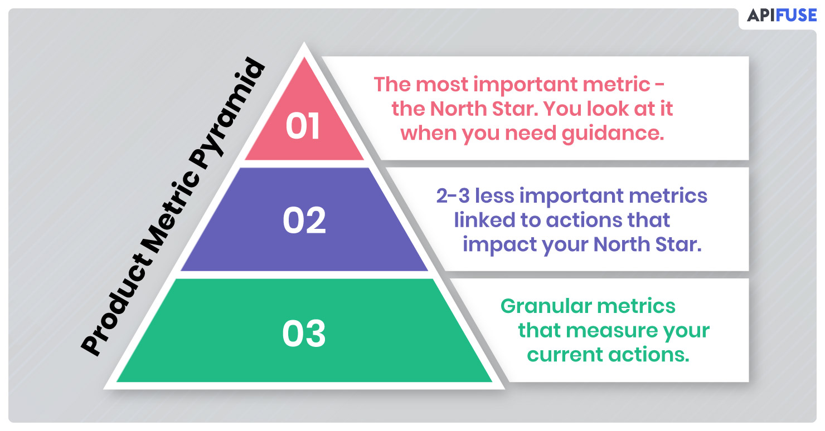

**Focus metric / North Star metric -**

This is the single most important measure of success that matters a lot to a company.

A North Star Metric (NSM) should be:

* A direct reflection of the company’s mission
* An indicator of how a company brings value to its customers.
* The only one of its kind. (Avoid having multiple NSMs as this tends to create complexity and confusion)
* The answer to the following question: What is the one metric that best represents the desired outcome of your company?

Which metric, if it were to increase today, would most accelerate my business’ flywheel?

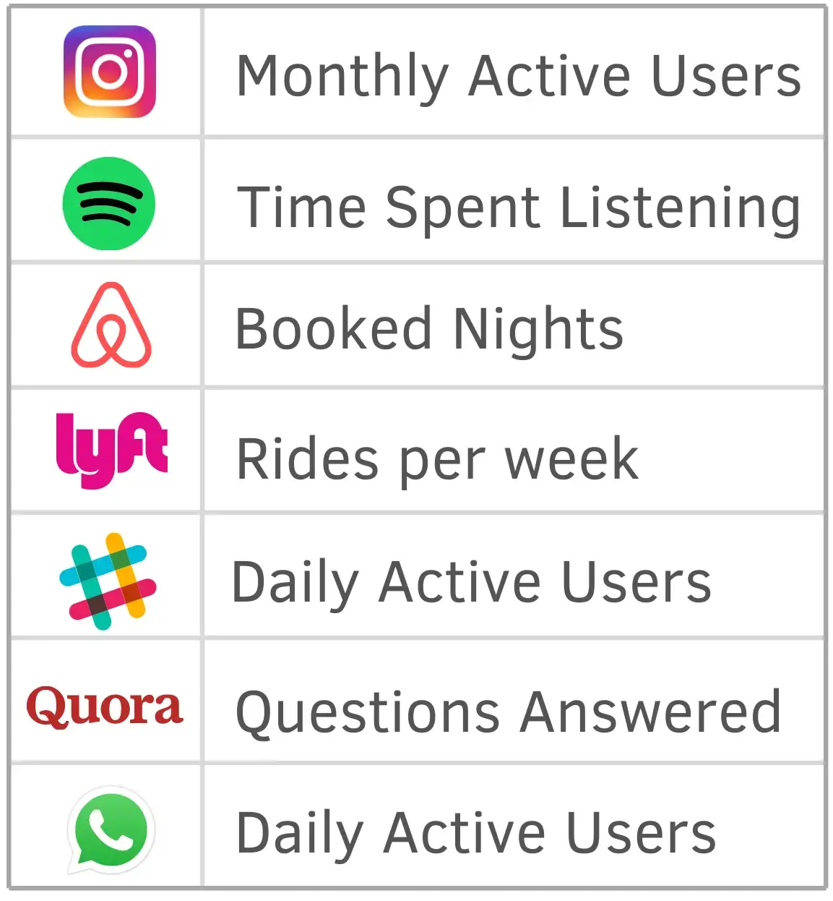

**Level 1 metric / Primary metric -**

* Primary metrics depict the desired outcome of a particular product, team, or initiative. This is unlike the NSM, which represents the desired outcome of the company as a whole.
* Level 1 (L1) or primary metrics should either directly contribute to the focus metric or act as a check to make sure the product is growing in a healthy direction.
* The primary metric can be more valuable than the NSM in the short-term because of its narrower focus, tighter feedback loop and more immediate association with the specific product, team, or initiative in question.
* For example, if a product’s focus metric is Weekly active user, a good L1 metric would be 7-day retention to ensure you aren’t spending precious marketing funds to acquire new users who leave after a day or two.

**Supporting/ Tracking/ Input metric / Level 2 metric -**

* Performance indicators which are set for the current initiatives that are most granular and mostly used for tracking the progress at lowest level.
* For example - There may be some targeted marketing or segmented offers that need to be checked.
* Supporting metrics are indicators that the primary metric is moving in the right direction.
* To take the retention example one step further, the Level 2 metric could be iOS app retention.
* Another could be a Level 2 metric such as the retention of a region or segment of customers.

